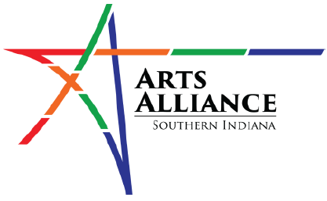

Questionnaire for Little Free Library

- Have you noticed the Little Free Library in the community? If so, what do you think of it?

- Have you borrowed any books or taken any art supplies from the Little Free Library? If so, what did you think of the selection and condition of the books and supplies?

- Have you donated any books to the Little Free Library? If so, what was your experience?

- Do you think the Little Free Library is a valuable addition to the community? Why or why not?

- Have you noticed any issues or challenges with the Little Free Library? If so, what were they and how do you think they could be addressed?

- Would you be interested in volunteering to help maintain the Little Free Library or organize events related to it?

- Are there any suggestions you have for improving the Little Free Library or making it more accessible to the community?

- Would you like to see more Little Free Libraries in the community?

- Do you have any other thoughts or comments on the Little Free Library or its impact on the community?

Please return this questionnaire to any branch of Harrison County Public Library. Thank you

